**Activity Rule:**

**Technical-> Activity**

**Purpose: is to Implement the Business logic .**

**- In PRPC Logic is available in the form of Methods, Functions & Built in Activities( API ) in Activity Rule**

**Parameters in Activity:**

**Label: Purpose is to Block execution of the Step or For adding Condition Parameters**

**Loop: Purpose is to add loop condition based on Property Type**

**When/Precondition: Purpose is to Add Pre Condition before executing Method/API**

**Method: Choose required method from dropdown/ Predefined Activities**

**StepPage:  Purpose is to Add New User Pages to Clipboard for debugging/To Access properties from that Reference Class**

**Jump/Postcondition/Transition: Purpose is to Add Post Condition After executing Method/API**

**======**

**Understand some basic Methods used in Every activity:**

**Page -New : Add new user pages to Clipboard for Debugging**

**Page- Remove: Remove user pages from clipboard after Debugging**

**Property -set:  we can assign values to Property**

**Create New Activity:**

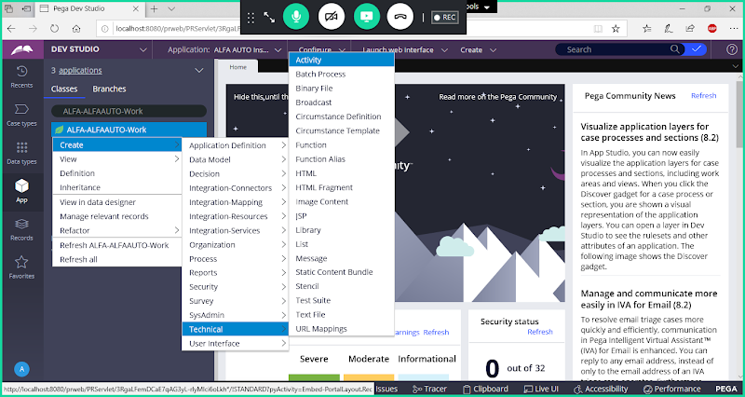

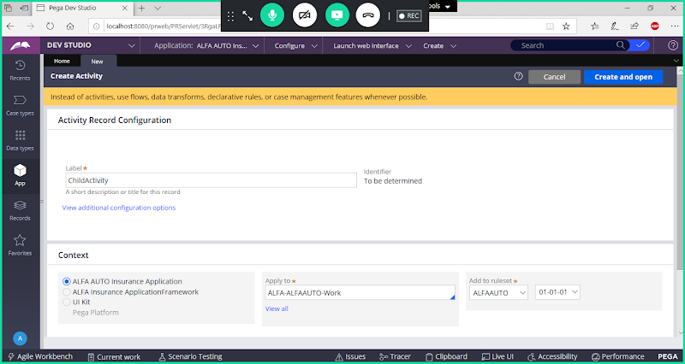

**Open & go to Pages & Classes**

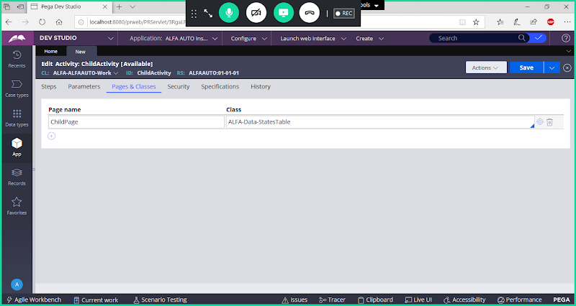

**Go to Steps Tab:**

**Add Page-New & Page-Remove**

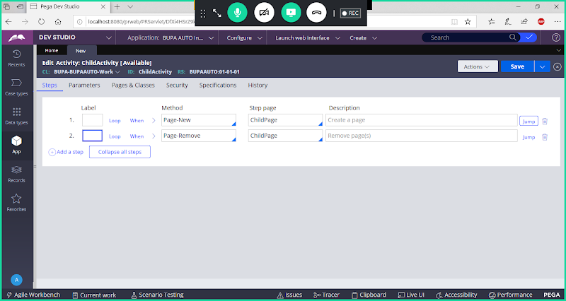

**Block Page-Remove ( When Debugging Activity you have to block Page-Remove).**

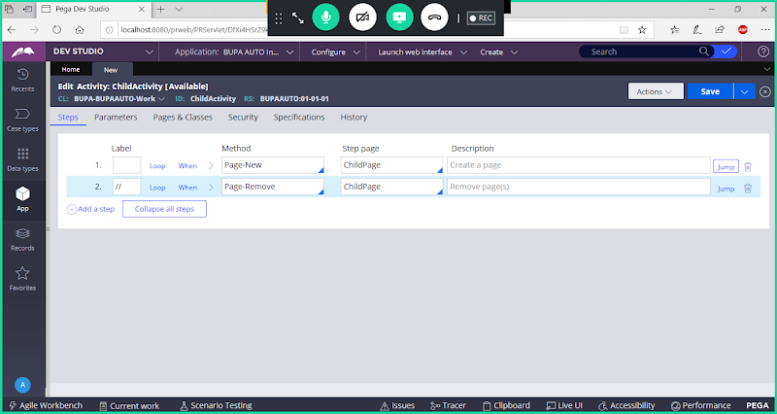

**Note: Once Debugging is Completed remove Label for Page-Remove**

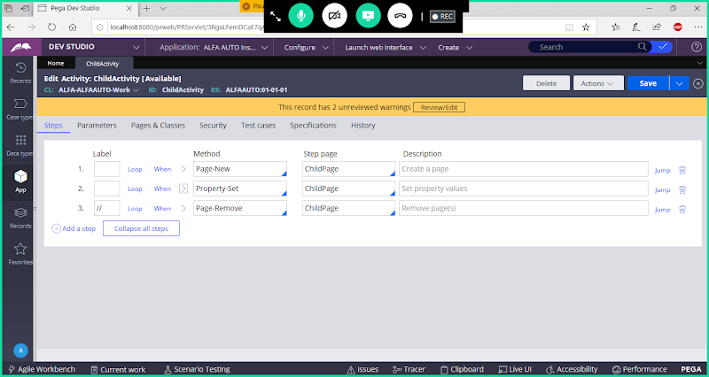

**Expand Property-set & Fill Parameters**

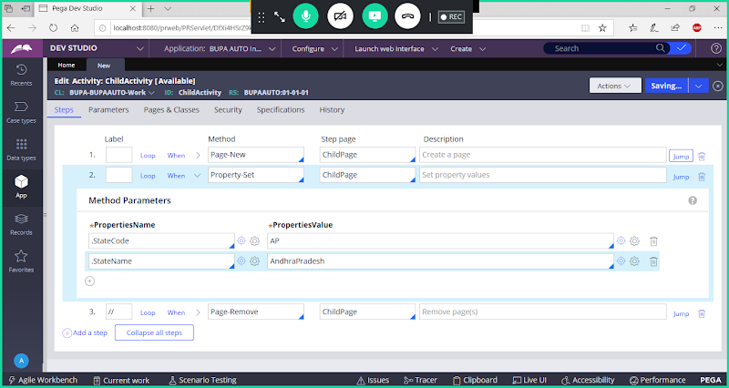

**Save Activity**

**Run Activity & Debug Using Clipboard:**

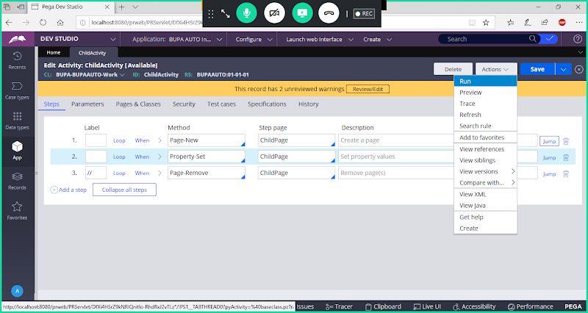

**Debug Activity Using Clipboard:**

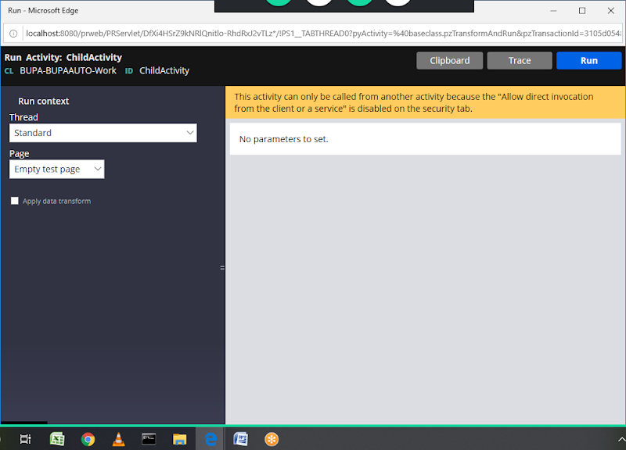

**Click on Run**

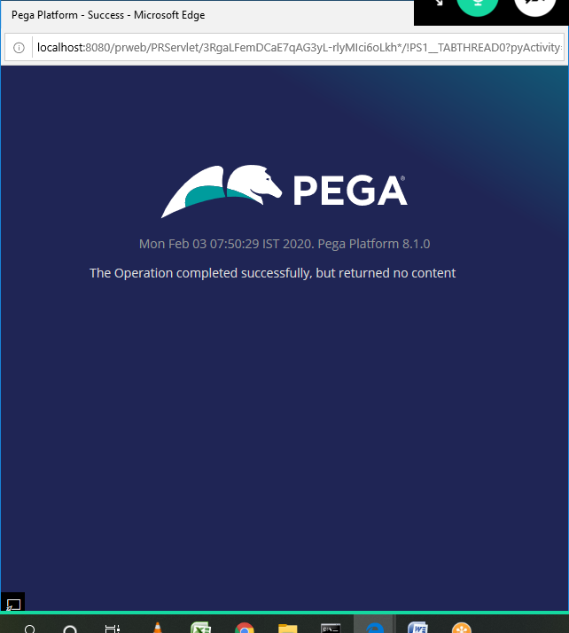

**Close this Blue Colour Window**

**Open Clipboard Using RunWizard.**

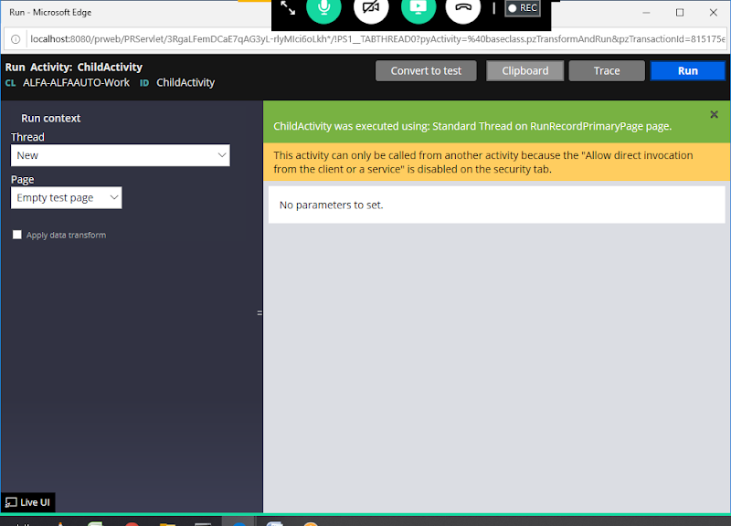

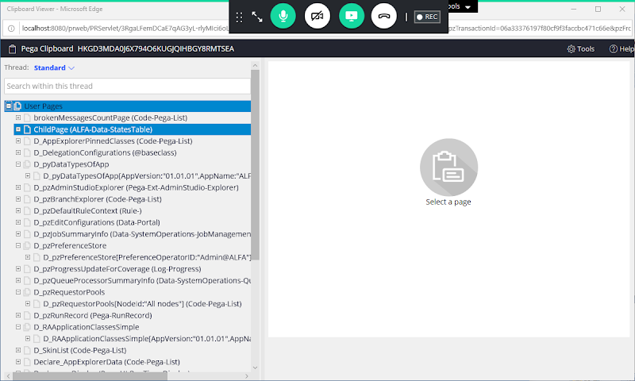

**Click on ChildPage**

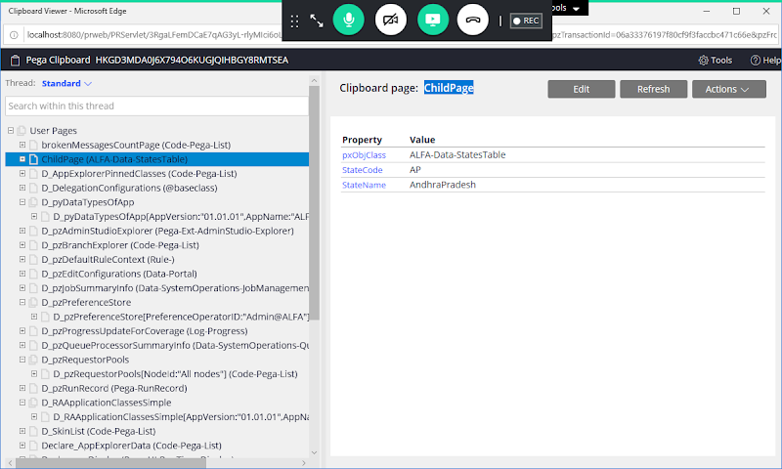

**Tracer:**

**Tracer is a Debugging Tool/ Testing Tool used by developers**

**Tracer will Records step by step execution details/Status of any type of rule in the in the application**

**By Default Tracer will debug Activities, Activity Steps, Data Transform & When Condition**

**How to Debug Activity using Tracer:**

**Run Activity:**

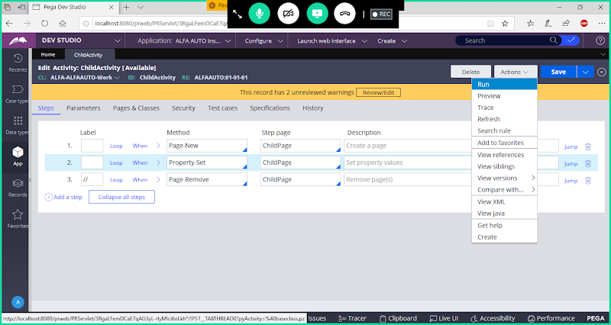

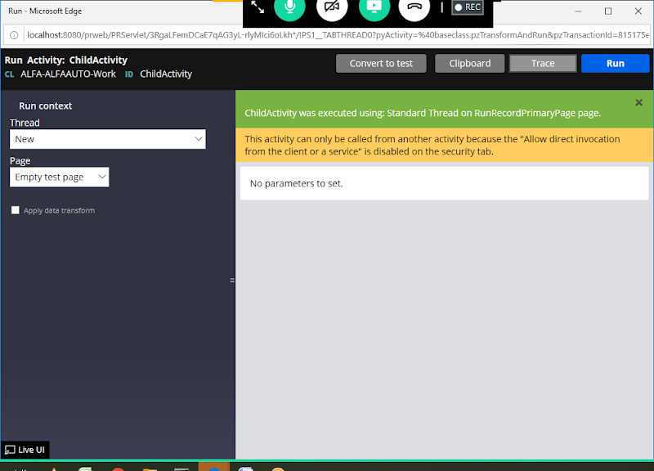

**From Above Wizard Click on Trace Button**

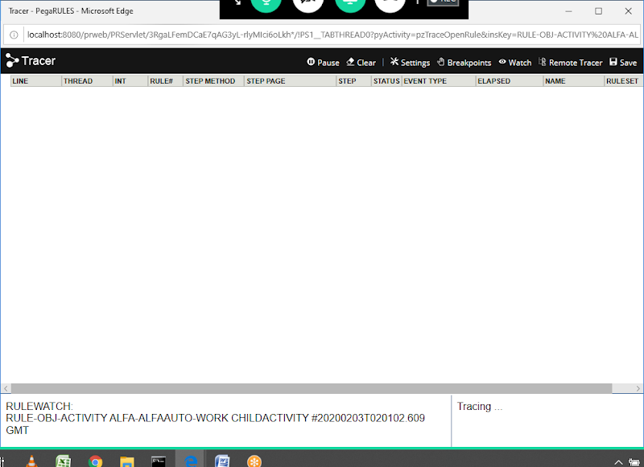

**Minimize Tracer**

**Now Click on Run From wizard**

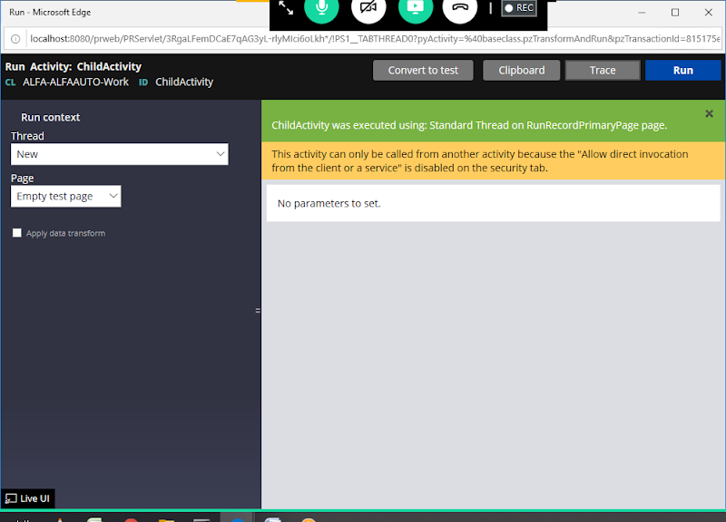

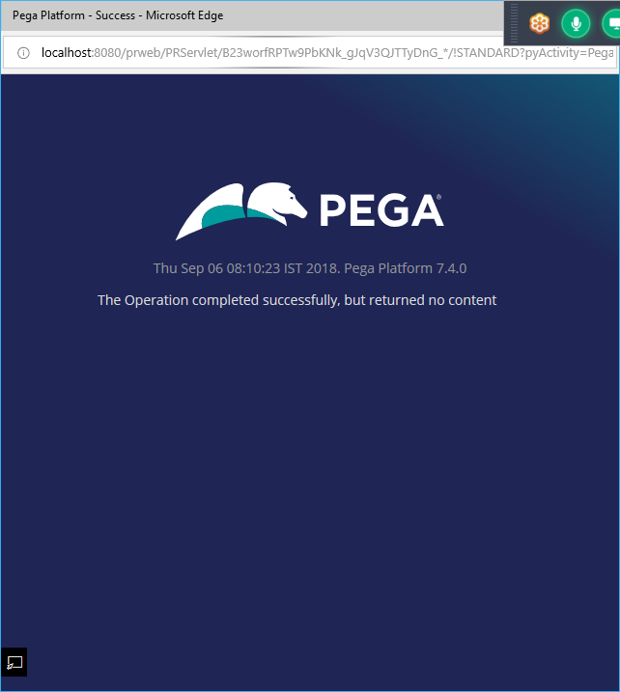

**Close above window.**

**Now Maximize Tracer to Check Activity Logs:**

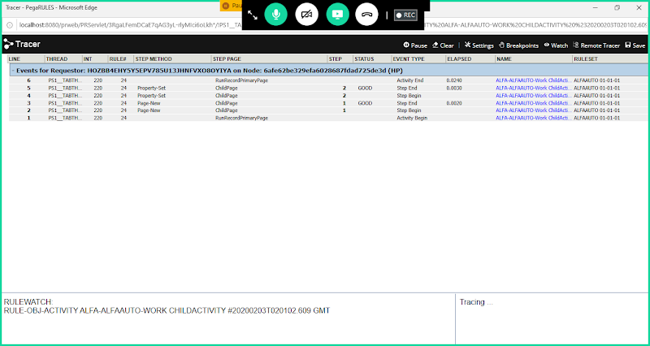

**Debugging:**

**Clipboard: In Run Wizard -> First Click on Run & Then Open Clipboard**

**Tracer: In Run Wizard -> First Open Tracer & then click on Run**

**============**